Empowered Youth, Small Grant, Great Outcomes
Jennifer Shingleton of Duke Memorial UMC shares how the youth group used a small grant from the NC Conference Creation Care Committee not just to create pollinator habitat, but also to educate, inspire, strengthen intergenerational relationships, and witness to the community about their love for God’s good creation.
The youth group at Duke Memorial UMC received a $665 NCC Creation Care grant last June to plant a pollinator garden on our campus. This project began with a youth group trip to the Earth Day Festival at Durham Central Park this past April. There we learned of the importance of native plants to local pollinator populations, which are a crucial part of our ecosystem but are facing decline. We knew of a neglected garden bed on our campus and decided that establishing a pollinator garden there would be a project with multiple benefits. Besides serving as a source of food and support for local pollinator populations, it would beautify an entrance that is used throughout the week for church members and organizations based in our building. The choice of native plants would also lessen the amount of maintenance needed going forward once the plants were established.
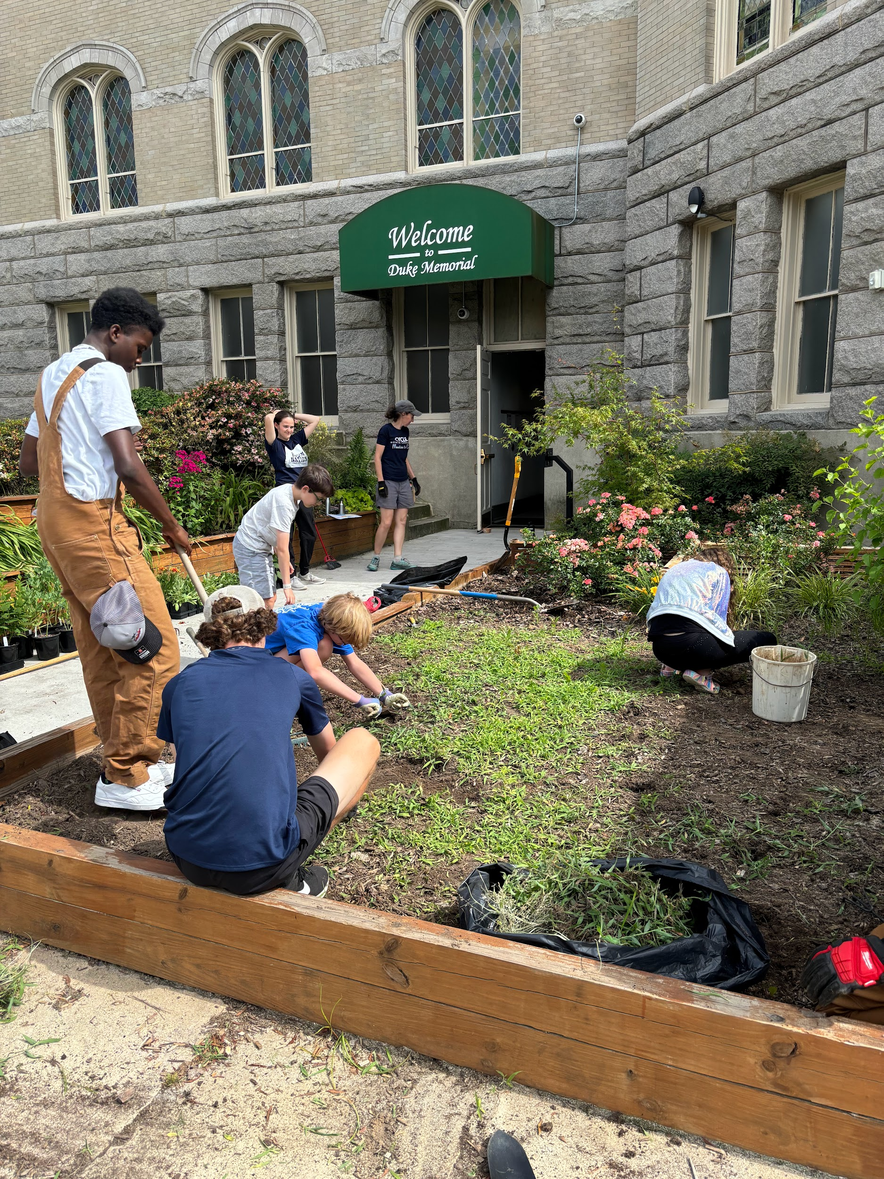
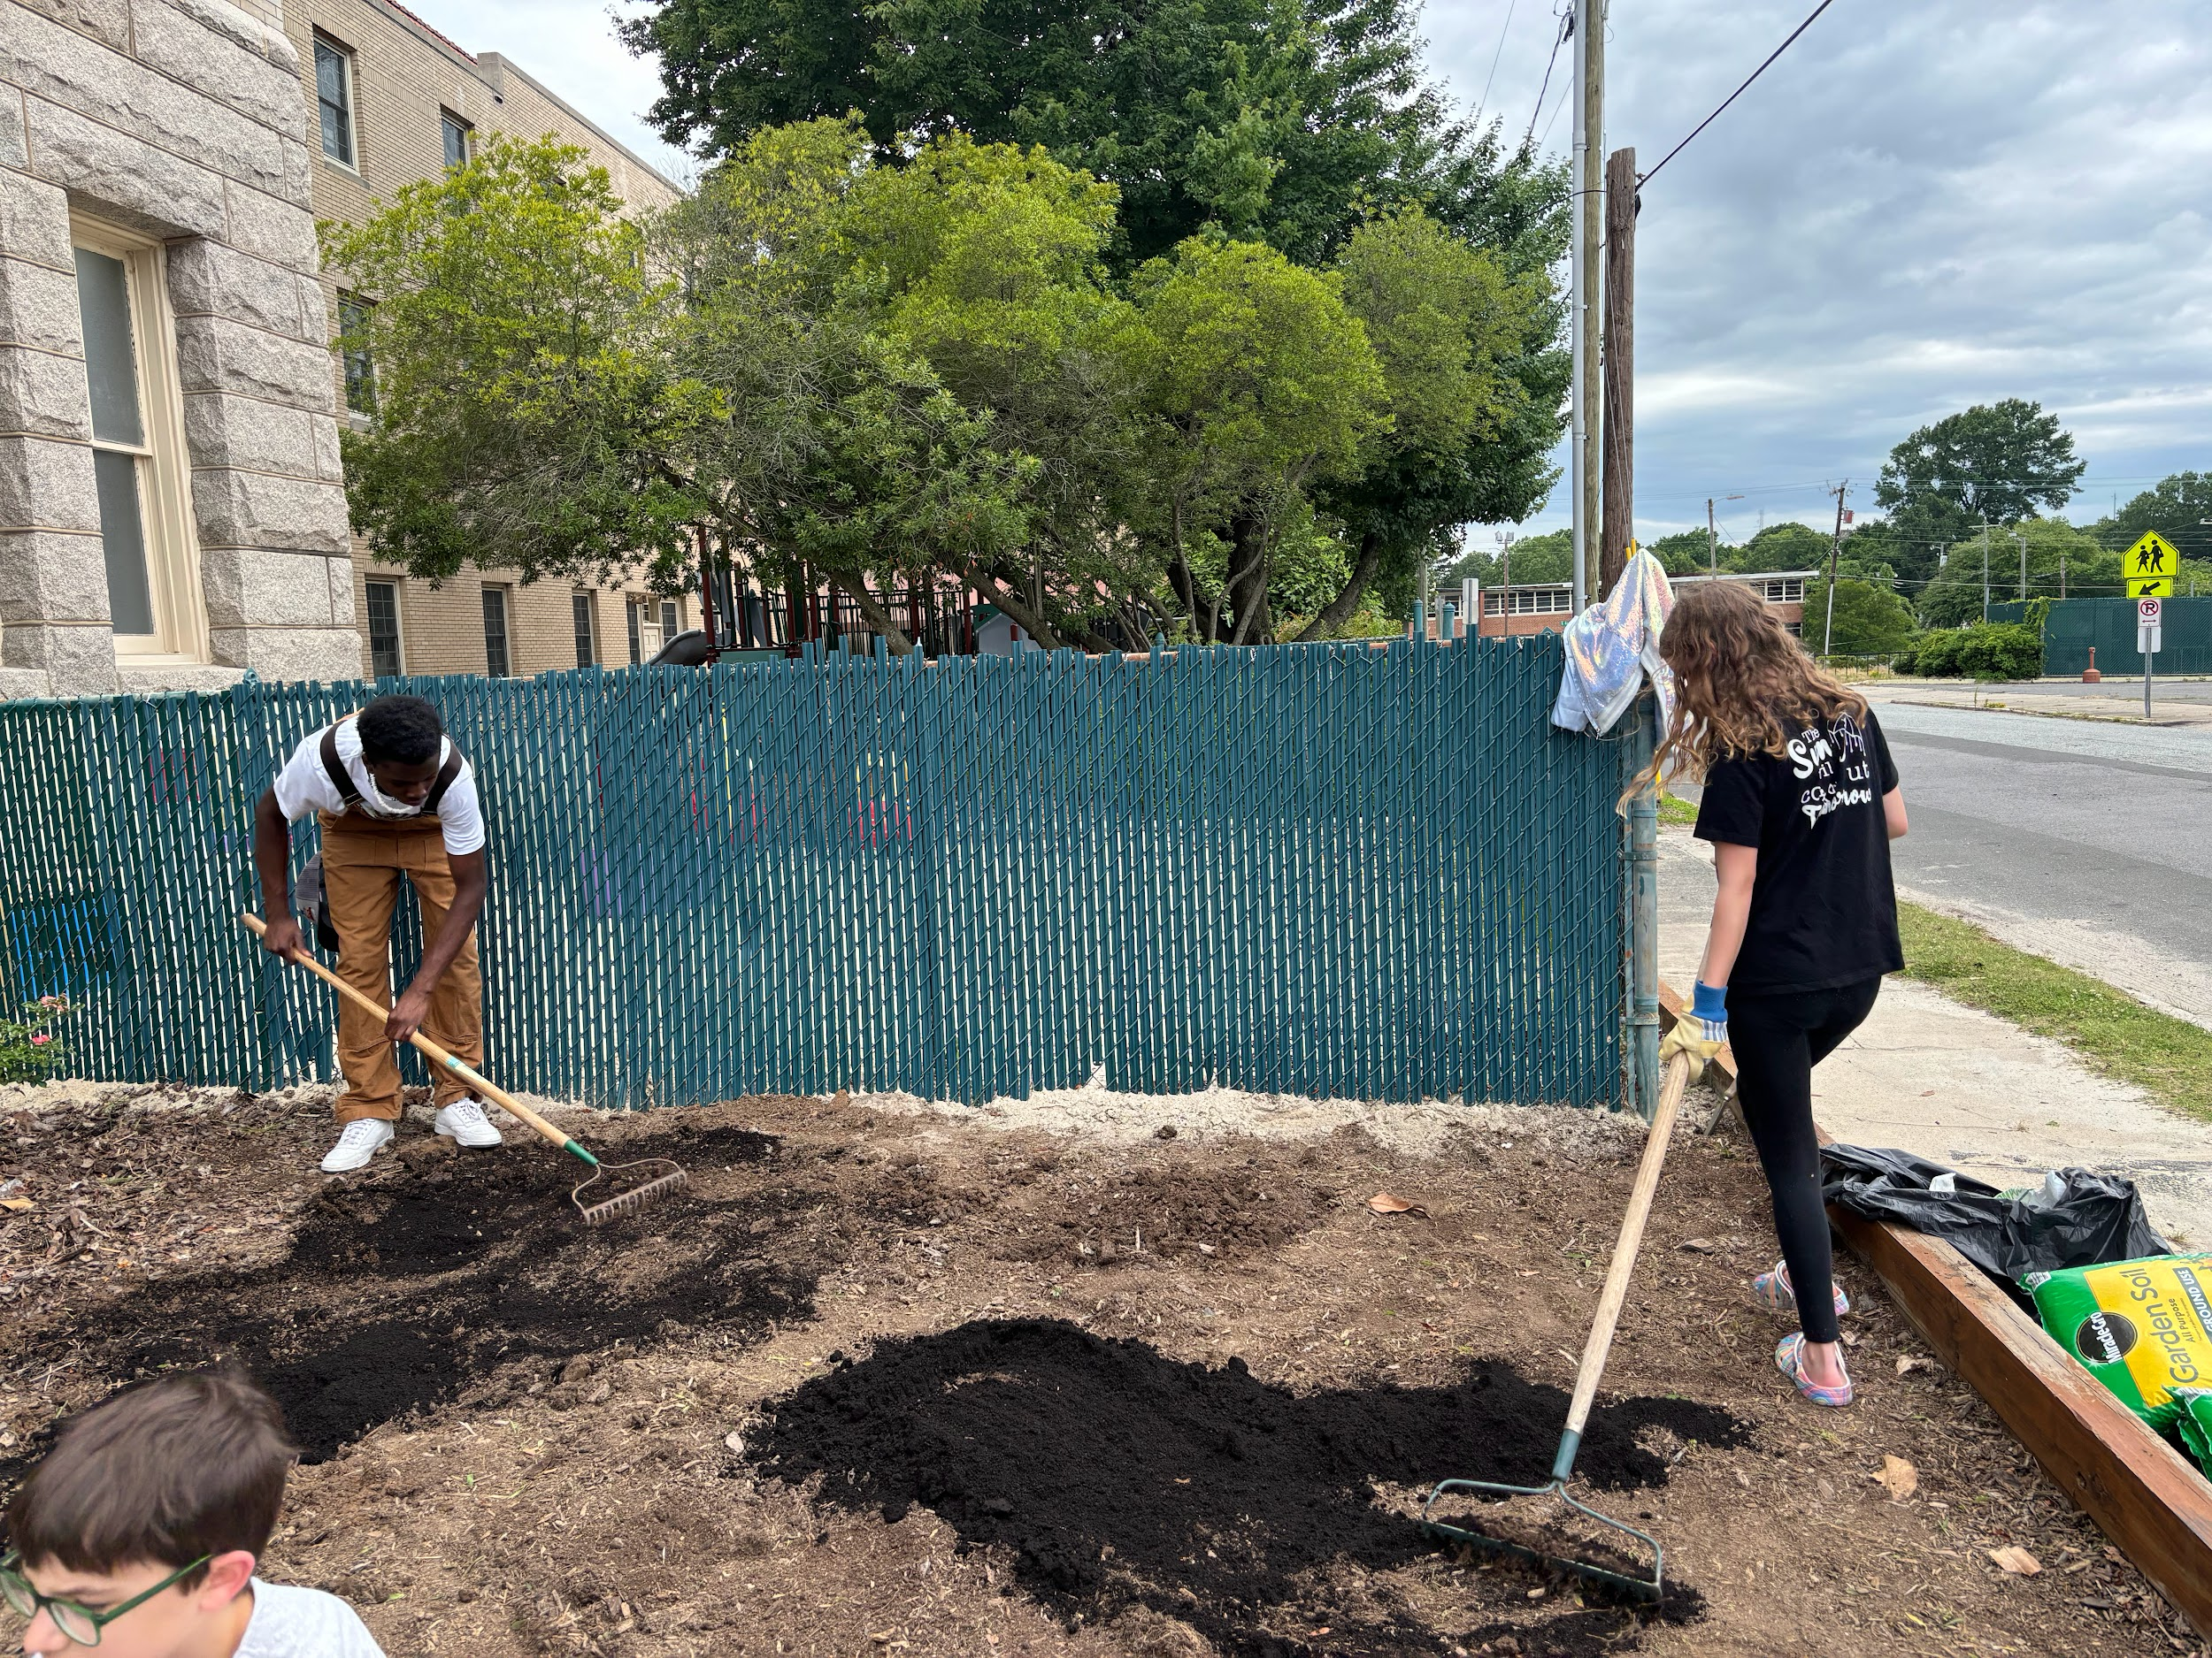
We partnered with Heather Bixler of Eno RIver Gardener for this project. Heather worked with us to design the layout and select the best native plants for the site. The native plants included milkweed (key for monarch butterfly caterpillars), phlox, black-eyed susan, and goldenrod. We utilized compost accrued through a church member’s Compost Now account, reinforcing the concept of returning organic matter to the soil for nourishment rather than burying it in landfills.
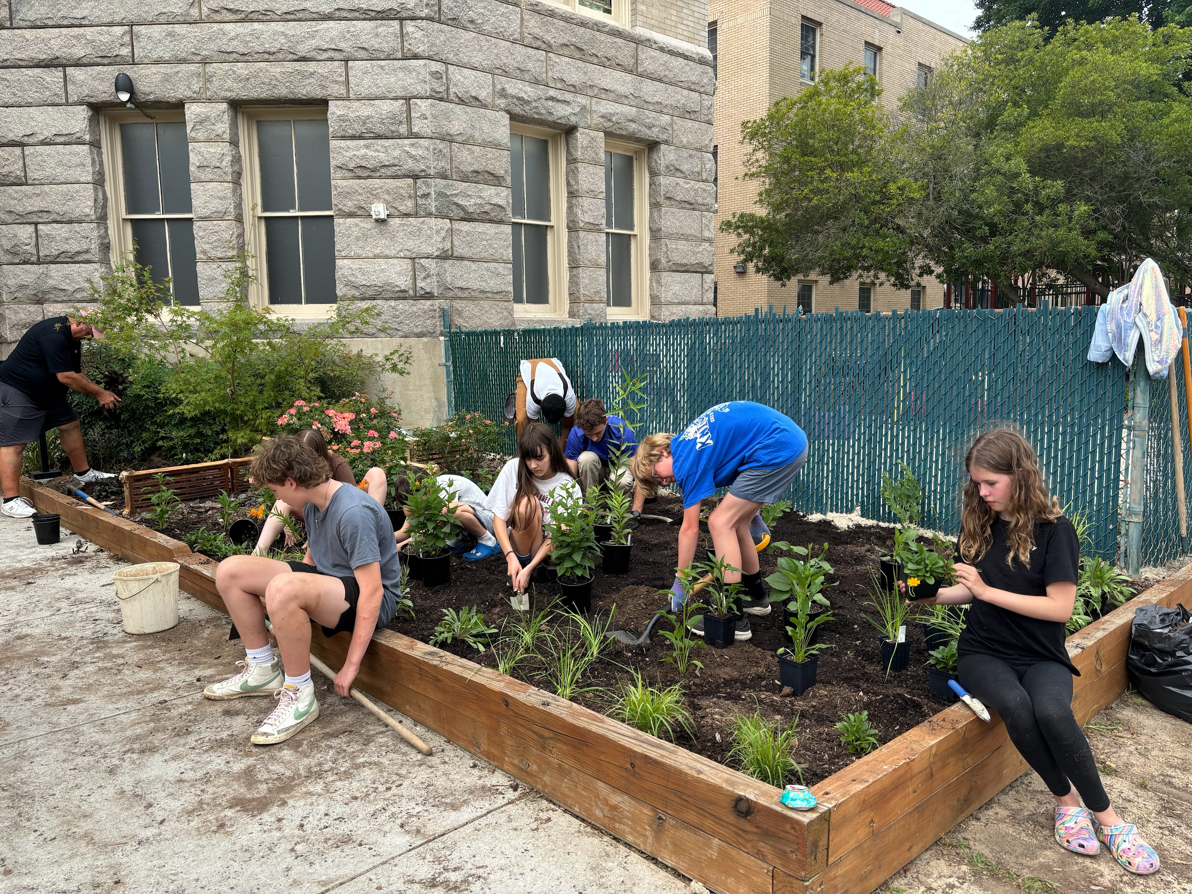
The youth and other church members spent an afternoon in June weeding, planting, and mulching the bed together. Since then, the plants have established themselves and are thriving, attracting numerous pollinators including bees and butterflies.

The pollinator garden in the back of the church has been very successful in attracting pollinators and is welcoming for visiting the church. When the youth group was establishing the garden, it gave a sense of connectedness to the church community. - Lena T.
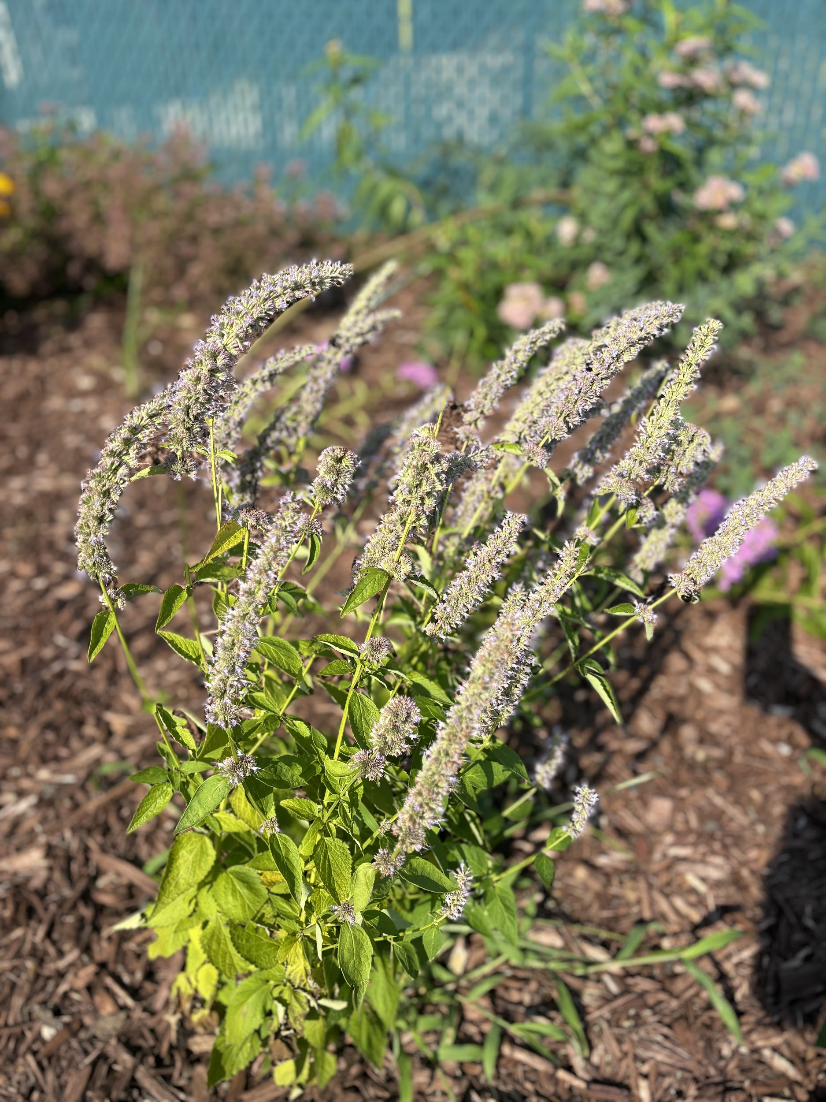
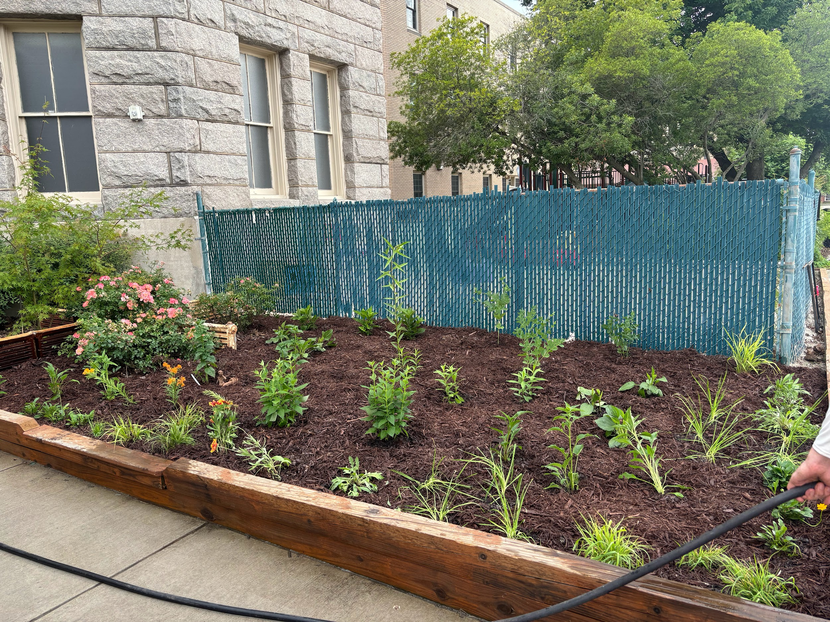
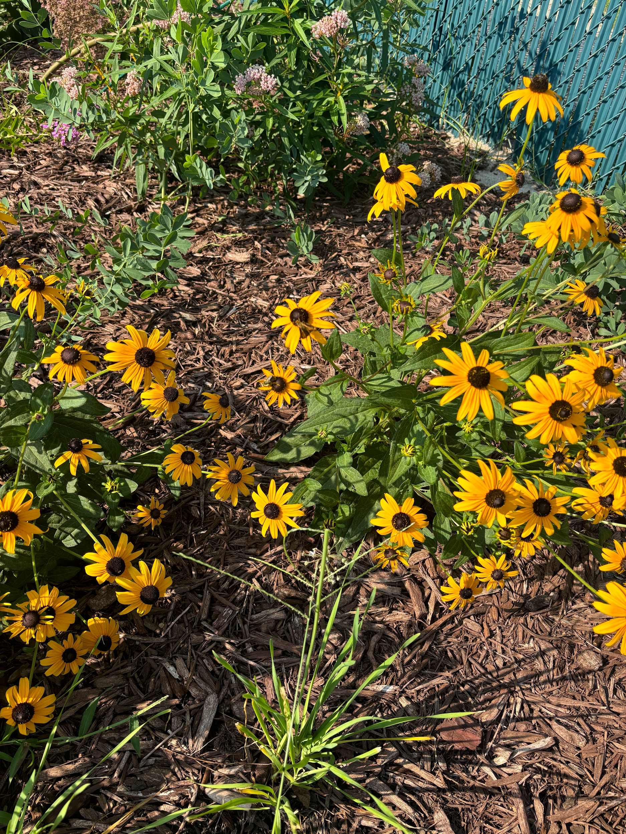
This garden project has served as a kick-starter for the youth group’s focus on learning about and addressing environmental issues. The garden is also a highly visible indicator of our church’s concern for environmental stewardship. We anticipate that by seeing the successful project that the youth were able to accomplish, others in the congregation will be inspired to pursue their own acts of creation care, both individually and as a community. We deeply appreciate the opportunity that the creation care grant gave us to carry out this work.

